Dashboard Design

Date | 24 September 2024
Team ID | Individual
Project Name | EV Market Performance & Sustainability Analytics Dashboard
Maximum Marks | 5 Marks

The EV Market Performance & Sustainability Analytics Dashboard presents electric vehicle sales, manufacturing, battery technology, vehicle range, charging efficiency, and environmental impact in a clear, interactive format. It helps business users compare market segments and make data-informed decisions.
Activity 1: Interactive and Visually Appealing Dashboard
The dashboard is designed for EV market strategists, business intelligence managers, and sustainability researchers. It follows these design principles:
- Clear and Intuitive Layout
- Use Appropriate Visualizations
- Colour and Theming
- Interactive Filters and Slicers
- Drill-Down Capabilities
- Responsive Design
- Custom Visuals and Icons
- Use of Infographics

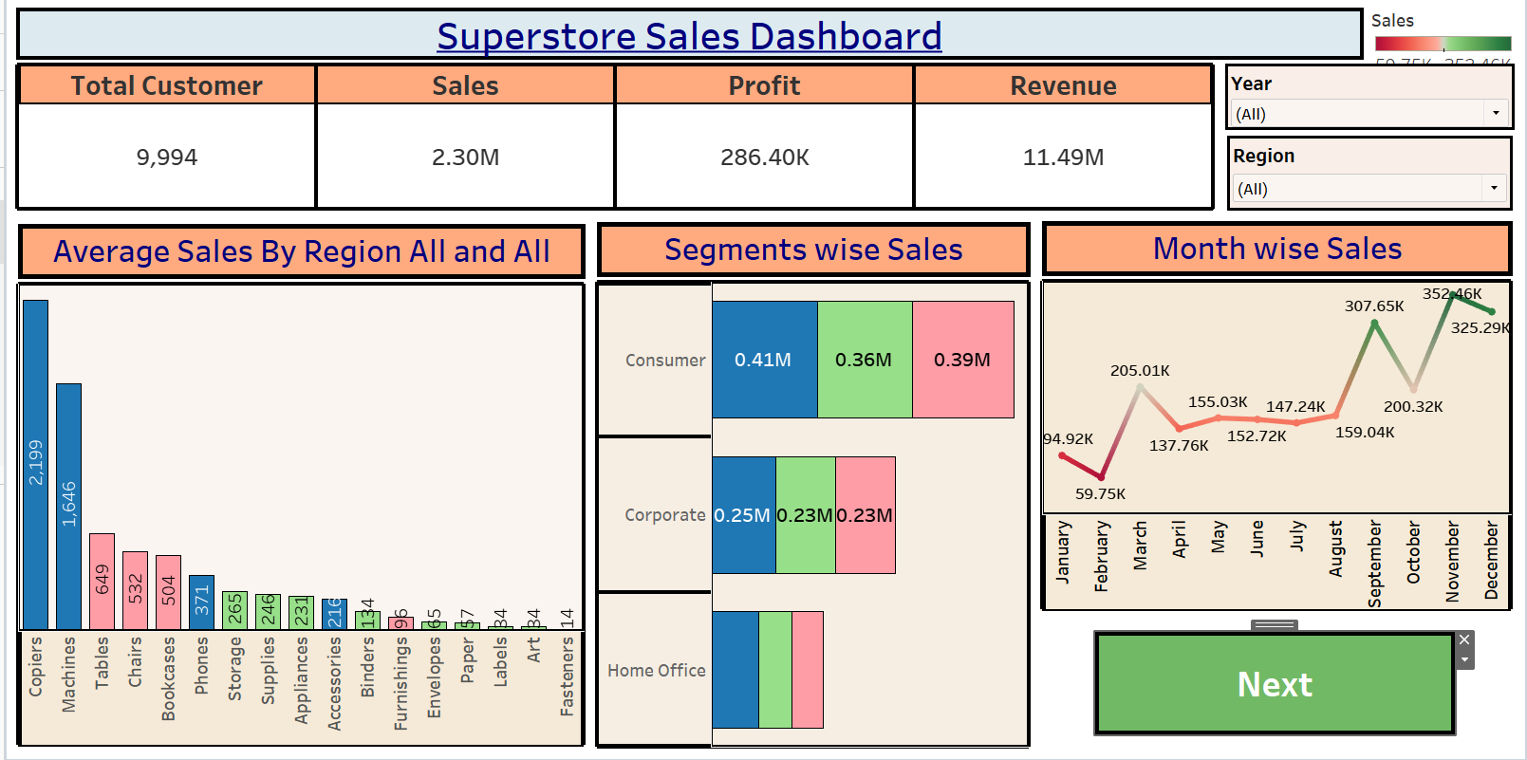
Major Outcomes from the EV Dashboard

The dashboard provides the following key outcomes:
- Overall EV Market Overview: The dataset reports approximately 1.55 billion annual sales units, an average vehicle price of $64,921, an average driving range of 324.54 km, and about 737.93K tons of annual CO₂ savings.
- Sales and Category Comparison: The sales trend and category charts help compare vehicle segments over model years and identify categories contributing most to recorded sales.
- Country-Level Production: The country bar chart compares recorded EV sales by manufacturing country, helping users explore geographic differences in the dataset.
- Battery Technology Mix: The battery technology chart compares sales associated with LFP, NMC, NCA, Sodium-Ion, and Solid-State battery types.
- Manufacturer Performance: The manufacturer bubble chart compares sales with customer ratings, helping identify manufacturers with strong sales and customer feedback.
Environmental Impact: The CO₂ savings measure supports sustainability comparisons, while interactive filters allow users to narrow analysis by year, country, category, battery type, or region.
Charging and Efficiency: The scatter plot compares maximum DC charging power with energy consumption in Wh/km; lower Wh/km generally indicates better energy efficiency.
Activity 2
Publish the completed dashboard on Tableau Public and paste the public dashboard link below:

Publish Dashboard on Tableau Public and Paste the Dashboard Public link below:
Example
https://public.tableau.com/views/SalesDashboard_17247660582000/Dashboard1?:language=en-US&publish=yes&:sid=&:redirect=auth&:display_count=n&:origin=viz_share_link

